**Problem Solving**

1. Build a **decision tree**using **ID3 algorithm** for the given training data in the table (Buy Computer data), and predict the class of the following new example :  **age<=30, income=medium, student=yes, credit-rating=fair**

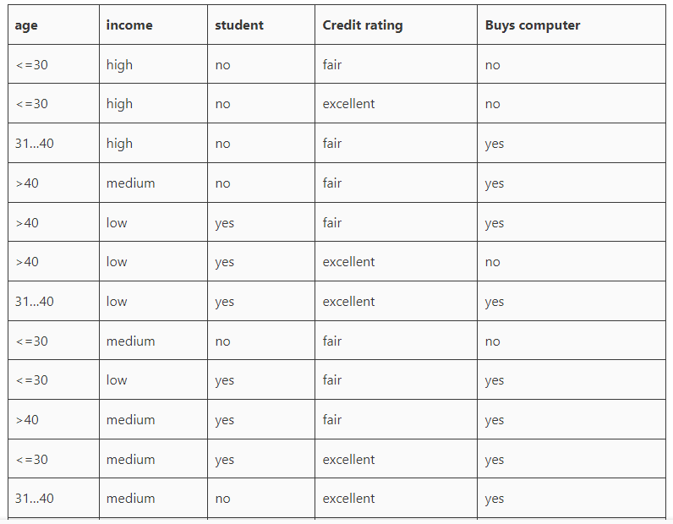

1. Build a **decision tree**using **CART algorithm** for the given training data in the table (Buy Computer data), and predict the class of the following new example:

**Past Trend = -ve , Open interest = Low , Trading vol.= low**

|  |  |  |  |
| --- | --- | --- | --- |
| Past Trend | Open Interest | Trading Vol. | Return |
| +ve | Low | High | Up |
| -ve | High | Low | Down |
| +ve | Low | High | Up |
| +ve | High | High | Up |
| -ve | Low | High | Down |
| +ve | Low | Low | Down |
| -ve | High | High | Down |
| -ve | Low | High | Down |
| +ve | Low | Low | Down |
| +ve | High | High | Up |

1. Consider a dataset that contains two variables: height (cm) & weight (kg). Each point is classified as normal or underweight. Based on the dataset, you need to classify the following new point as normal or underweight using the **KNN algorithm**.

New data point (x1, y1), and we need to determine its class



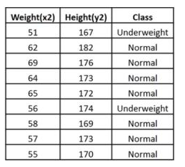

1. Consider the car theft problem with attributes Color, Type, Origin, and the target, Stolen can be either Yes or No. Based on the dataset, you need to classify the following new car **(Red SUV Domestic) is getting stolen or not using Naïve Bayes algorithm.**

